AI Visualization Examples for Recreational Area Reporting
This document provides examples of common chart types used to explain AI model results and summarize data in ways that are understandable to stakeholders.

Line Chart – Time-Based Data
Line charts are ideal for showing trends over time, such as attendance across multiple months.
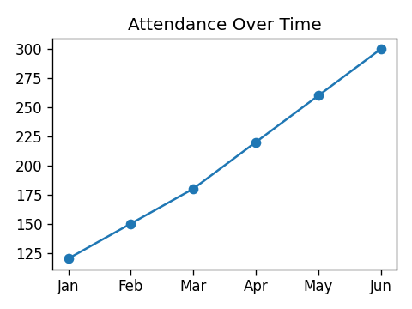

Bar/Column Chart – Comparing Multiple Series
Bar and column charts work well when comparing multiple categories, such as activity popularity.
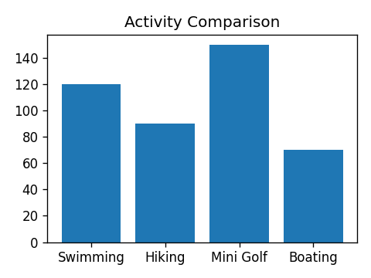

Pie Chart – Showing Parts of a Whole
Pie charts are useful when showing percentages of a whole, such as visitor percentages by season.
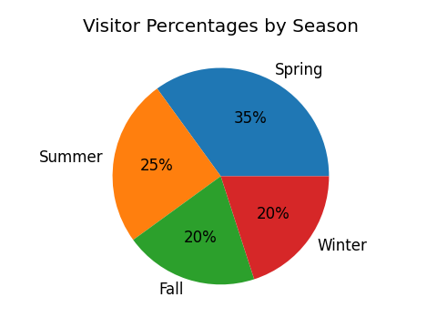

Scatter Plot – Showing Relationships
Scatter plots help identify relationships and correlations between two variables, such as temperature and attendance.
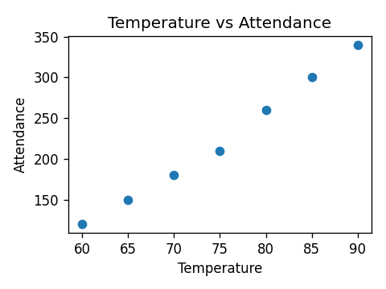

Histogram – Showing Distribution
Histograms display the distribution of numerical data, such as attendance broken into age ranges.
